EXPT NO:5 | DEVELOP INTERACTIVE DASHBOARDS FOR DYNAMIC DATA EXPLORATION USING TABLEAU AND POWERBI
DATE: 24.07.2026

PRE-LAB QUESTIONS (PROVIDE BRIEF ANSWERS TO THE FOLLOWING QUESTIONS)
- What is dynamic data exploration in BI tools, and why is it important?
Answer:
Dynamic data exploration in BI tools refers to the ability to interactively analyze and explore data by changing views, applying filters, and modifying visualizations in real time. It is important because it allows users to discover hidden patterns, identify trends, compare different categories, and make faster data-driven decisions without manually processing large amounts of data.

- What are slicers and filters, and how do they enhance dashboard interactivity?
Answer:
Slicers and filters are interactive tools used to display only specific portions of data in a dashboard. Filters allow users to limit data based on conditions such as date, location, or category, while slicers provide a visual way to select values. They enhance dashboard interactivity by allowing users to customize their analysis and focus on the information that is most relevant to them.

- How do Tableau and Power BI support drill-down and drill-through features?
Answer:
Tableau and Power BI support drill-down and drill-through features by allowing users to move from high-level summaries to detailed information. Drill-down enables users to explore data hierarchies, such as moving from continent-level data to country-level and city-level data. Drill-through allows users to open a detailed report or page related to a selected data point, helping users perform deeper analysis.

- What is the role of parameters in creating interactive dashboards?
Answer:
Parameters allow users to dynamically control certain aspects of a dashboard, such as changing calculations, selecting measures, or modifying views. They help create flexible and interactive dashboards by allowing users to adjust analysis options without changing the underlying data structure.

- Name some advanced interactivity features in Tableau and Power BI.
Answer:
Some advanced interactivity features in Tableau include dashboard actions, parameter controls, story points, highlighting, and interactive filters. In Power BI, advanced features include drill-through pages, bookmarks, tooltips, slicers, Q&A visuals, and cross-filtering between visualizations. These features improve user engagement and help users perform detailed data analysis.

IN-LAB EXERCISE:
OBJECTIVE:
To design and develop interactive dashboards in Tableau and Power BI for dynamic data exploration, enabling users to analyze, filter, and drill down into data for deeper insights.
PROCEDURE:
- Data Collection:
    - Import datasets from sources such as Excel, CSV, SQL Server, or online APIs.
    - Dataset: Retail Sales Dataset with fields such as Order Date, Region, Product Category, Sales, Profit, Quantity.
- Data Preparation and Transformation:
    - Ensure proper date formats for time-based analysis. o Handle missing or incorrect values.
    - Create calculated fields (e.g., Profit Margin %, Sales Growth %, Year-to-Date Sales).
- Data Aggregation and Hierarchies:
    - Create hierarchies (e.g., Year → Quarter → Month → Day).
    - Aggregate data by region, product category, or customer segment.
- Designing Interactive Elements:
    - Filters & Slicers: Allow filtering by product category, date range, or region. o Parameters: Let users switch between KPIs (e.g., Sales vs. Profit). o Drill-down: Enable users to explore data from summary to detail.
    - Tooltips: Add contextual details when hovering over data points.
- Dashboard Development:
    - Tableau: Use interactive filters, parameter controls, and highlight actions.
    - Power BI: Use slicers, bookmarks, and drill-through pages.
    - Add KPI cards for key metrics like Total Sales, Total Profit, Top Selling Product. o Use maps for regional sales analysis, line charts for trends, and bar charts for category comparisons.
- Testing Interactivity:
    - Ensure slicers and filters update all relevant visuals dynamically.
    - Test drill-down and drill-through functionality for accuracy.
- Publishing and Sharing:
    - Tableau: Publish on Tableau Public or Tableau Server.
    - Power BI: Publish to Power BI Service and share via workspace access or public link.
Experiment Dataset:
Retail Sales Dataset
Fields Used:
  - Order Date – Date of the order
  - Region – Sales region
  - Product Category – Category of product sold
  - Sales – Sales revenue
  - Profit – Net profit from the order
  - Quantity – Units sold

Power BI:

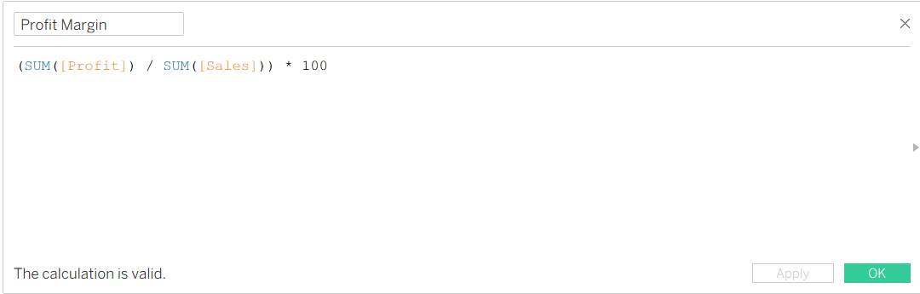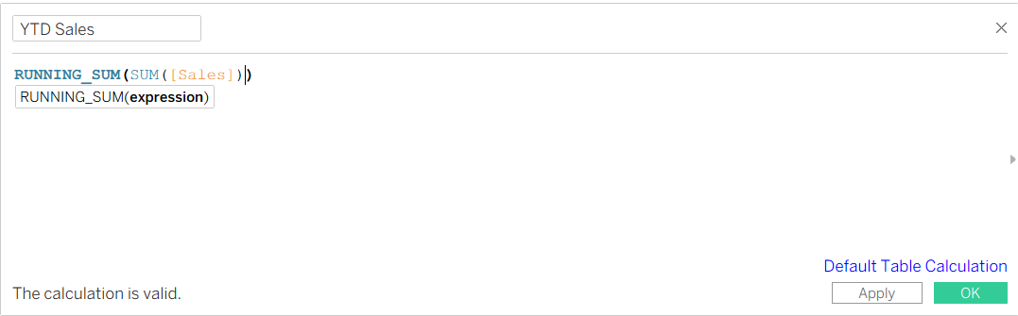

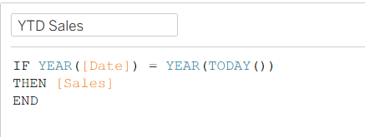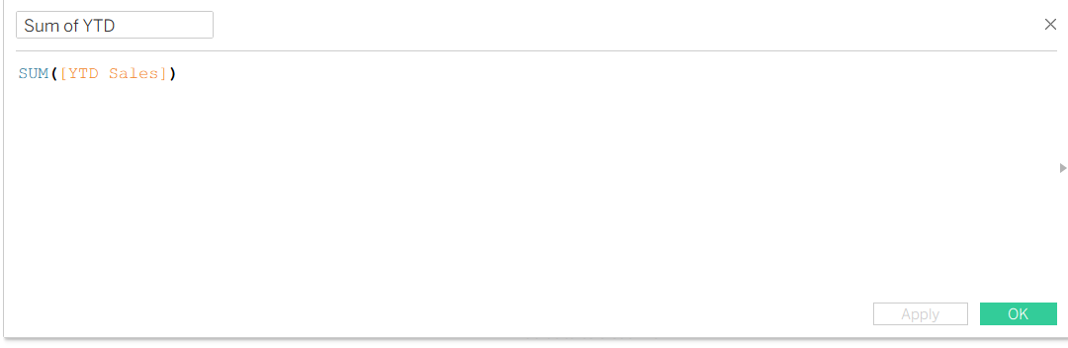

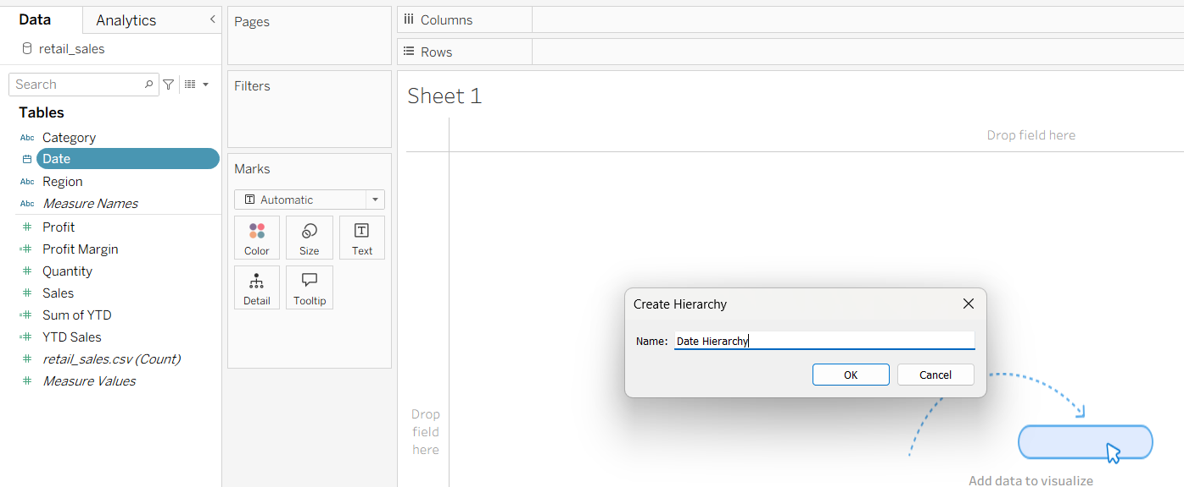

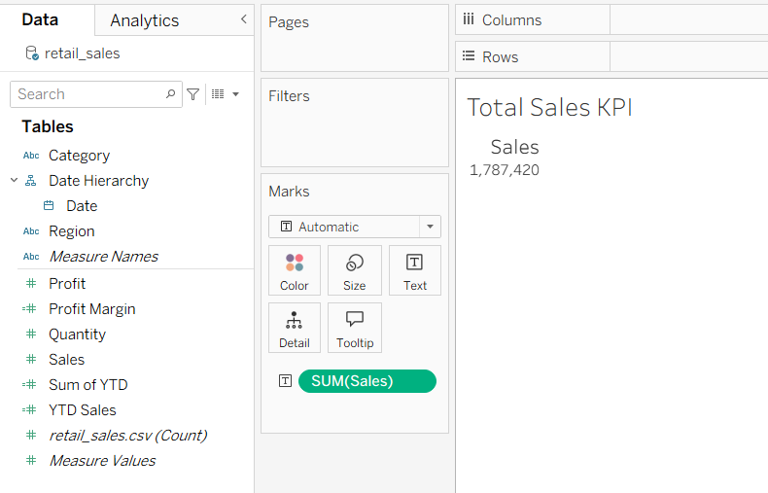

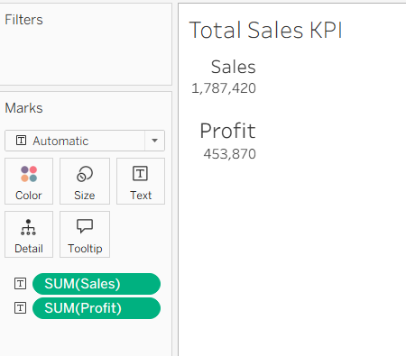

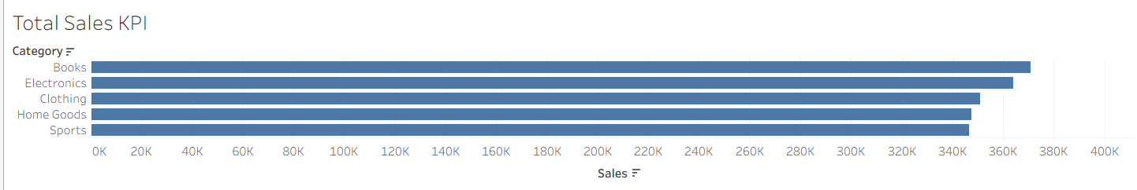

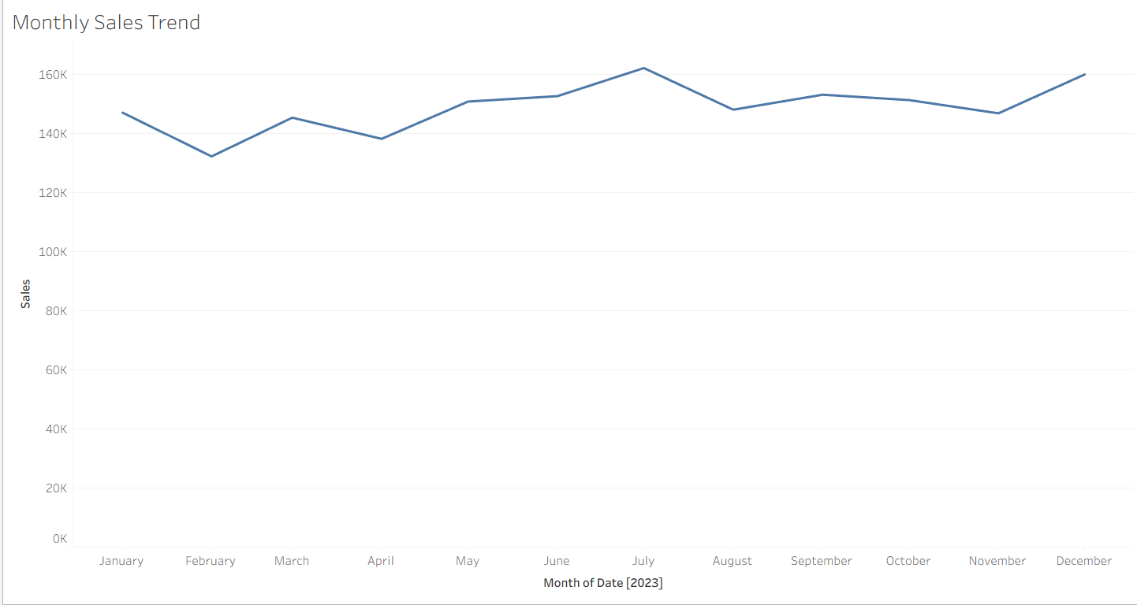

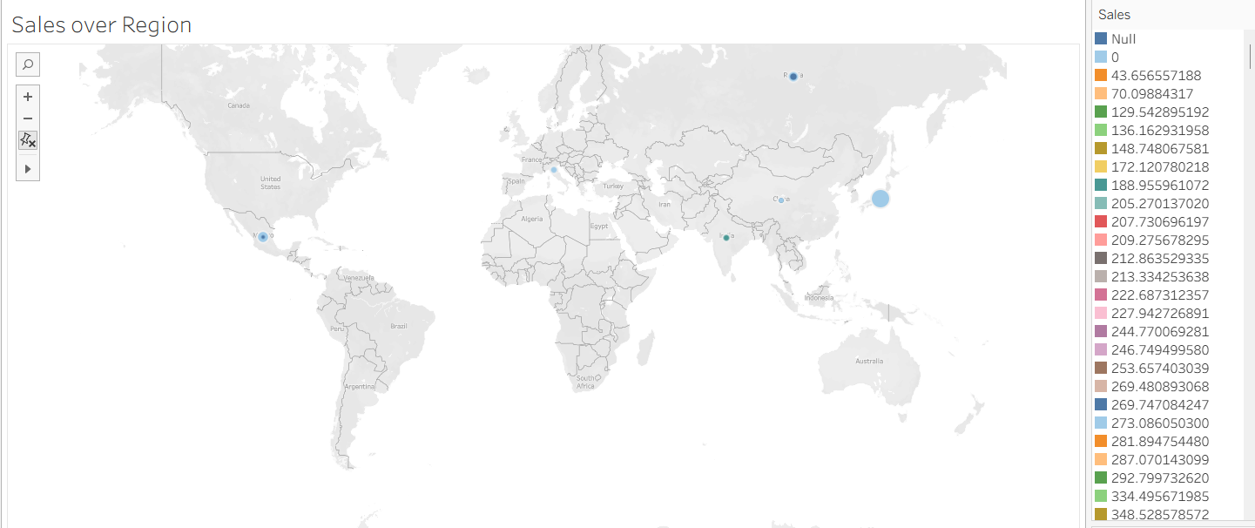

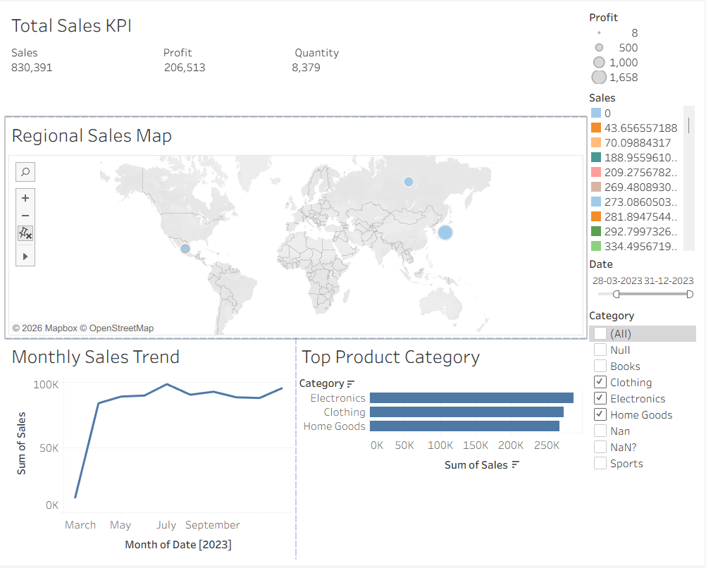

Power BI:
https://app.powerbi.com/groups/me/reports/c09d823b-17d5-4394-b6eb-153a1bf2c681/f8cc39233071c20262b0?experience=power-bi
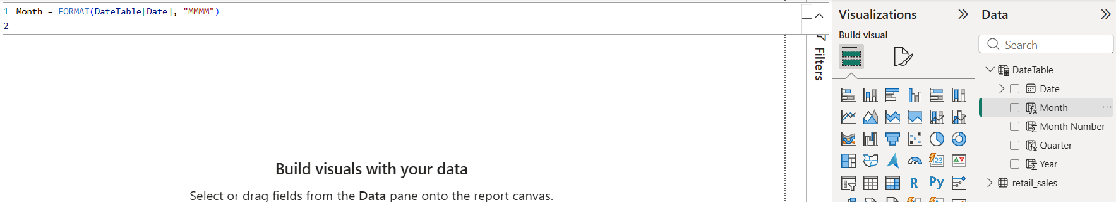

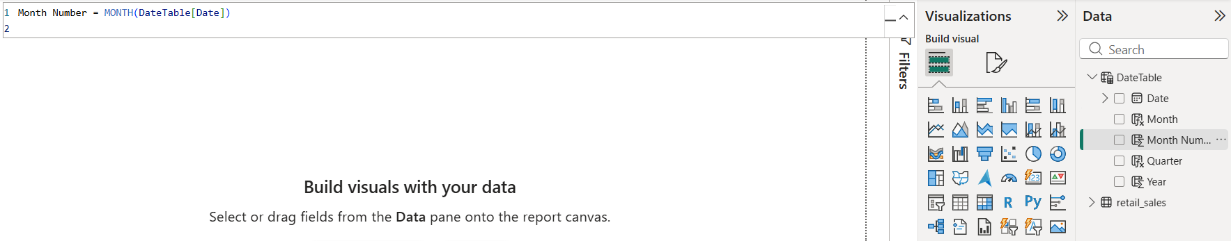

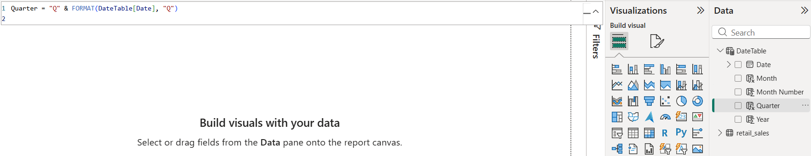
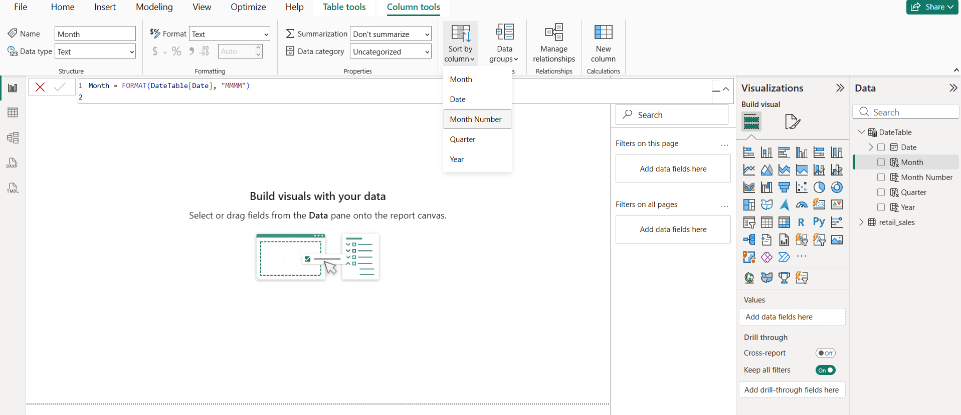

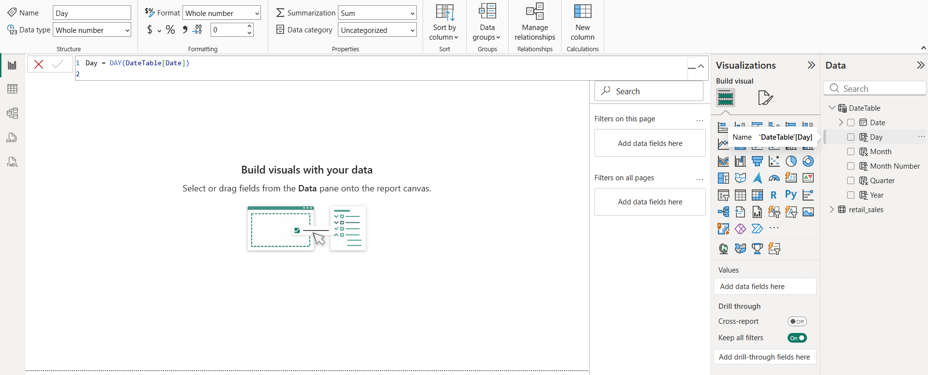

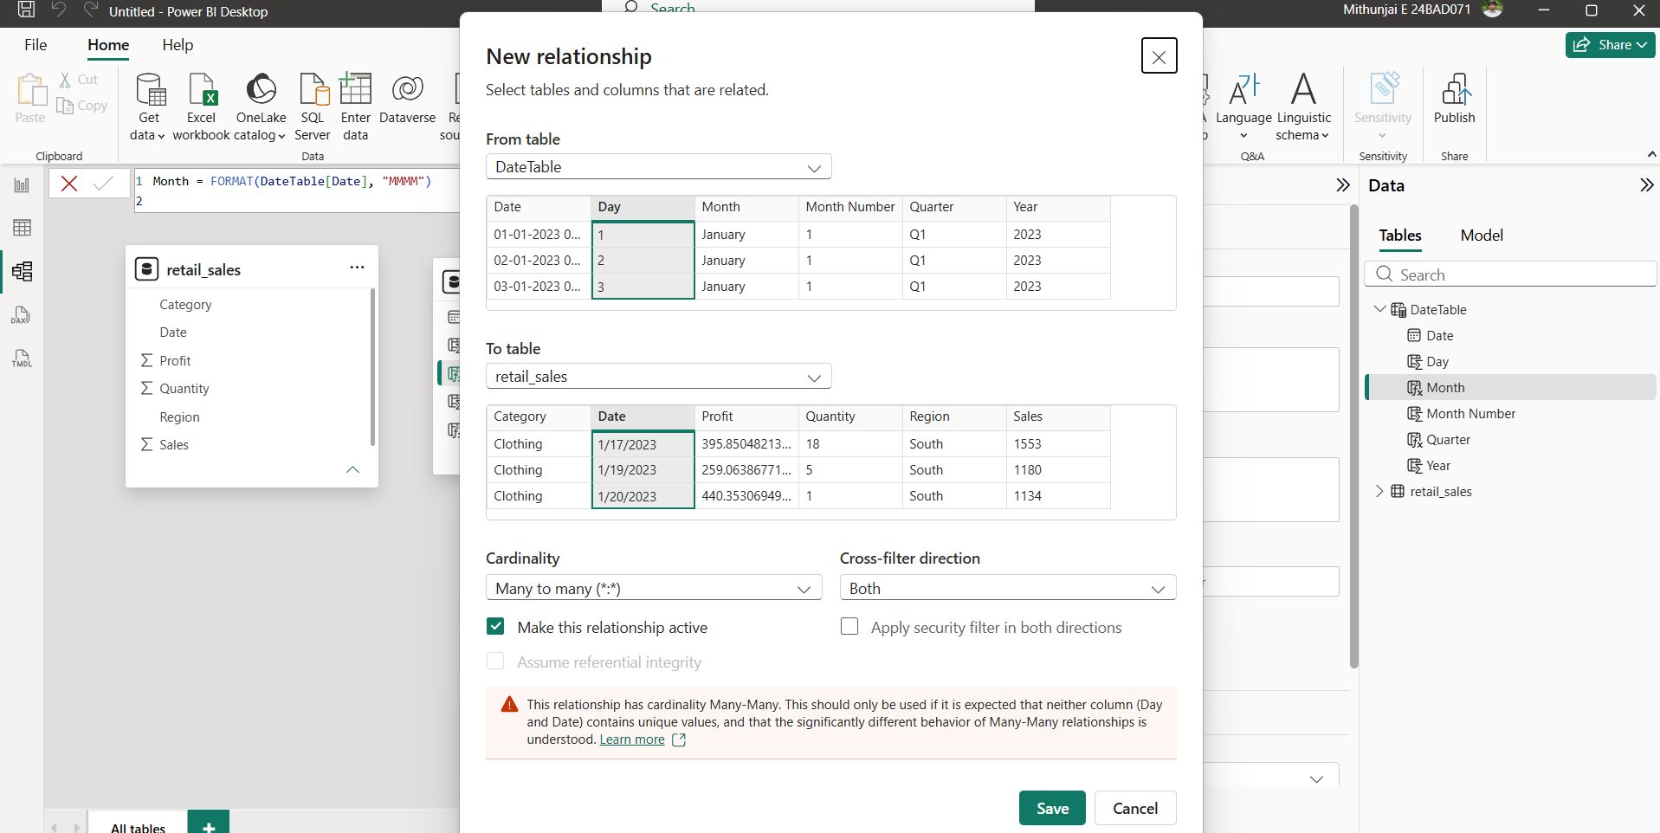

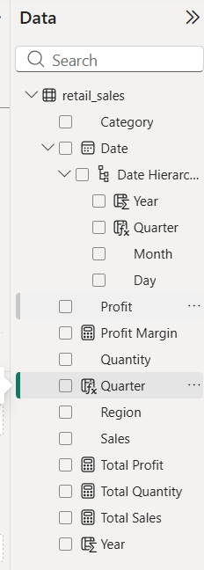

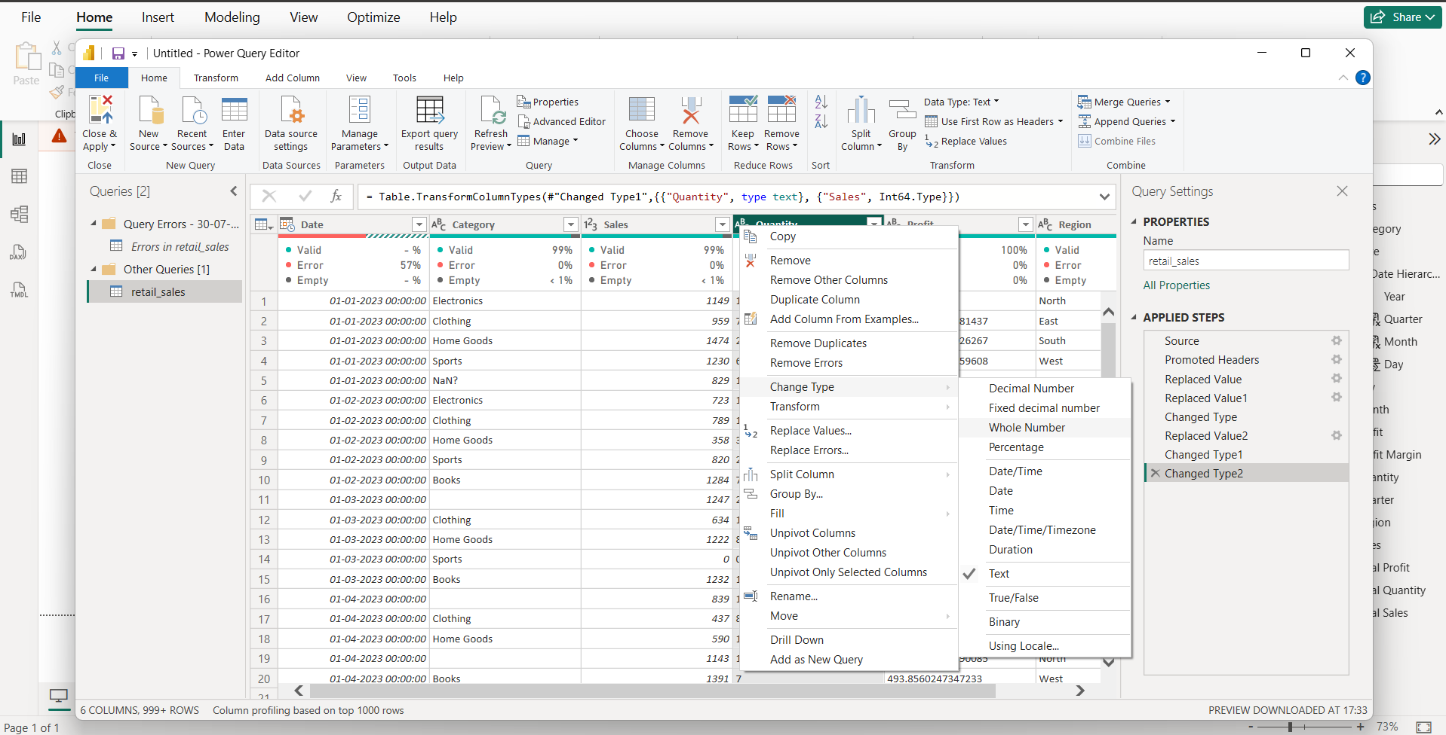

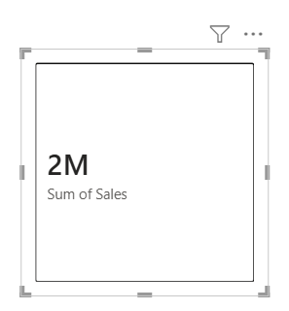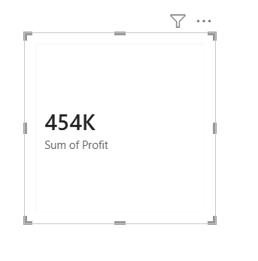

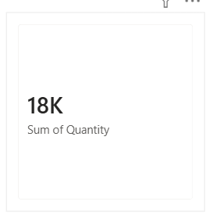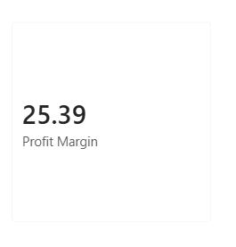

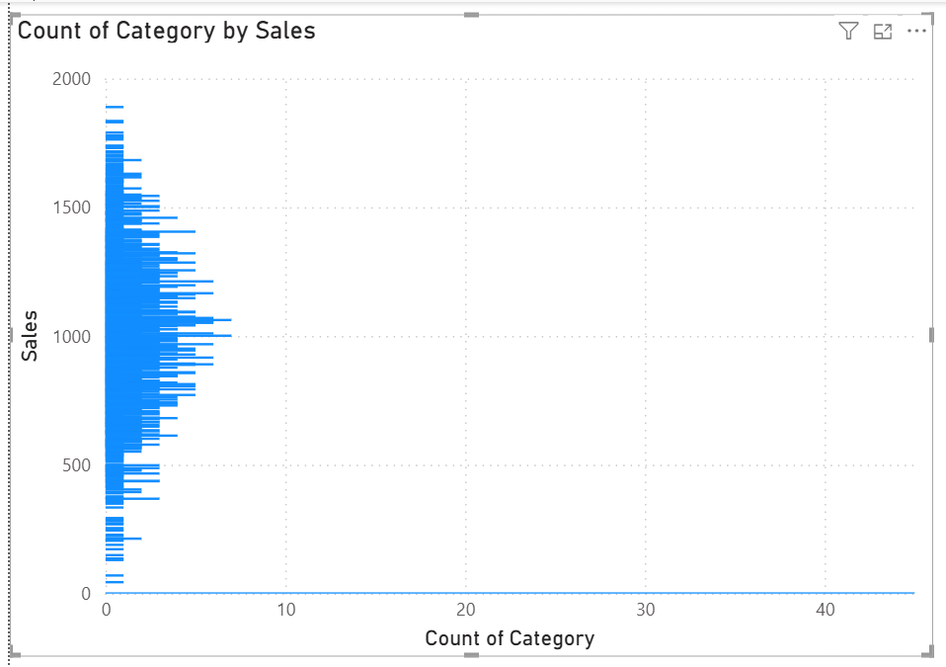

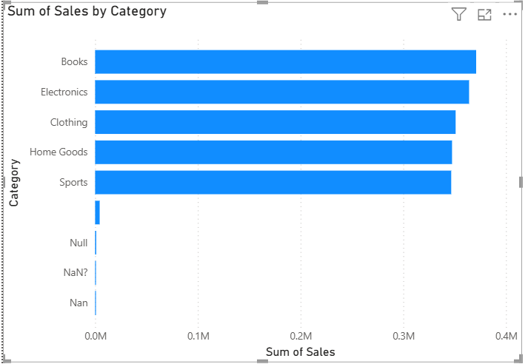

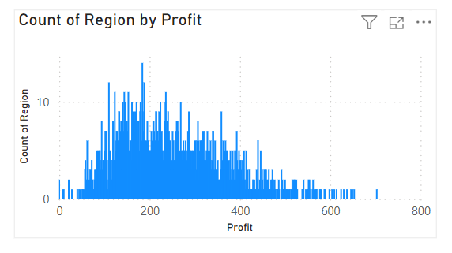

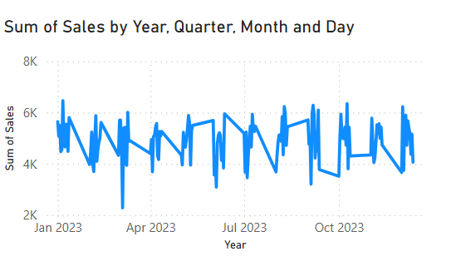

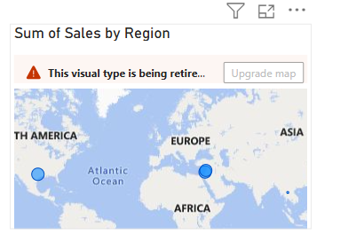

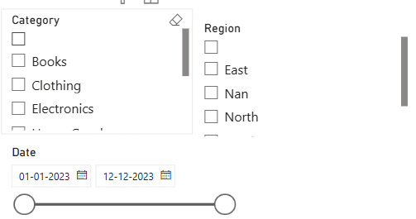

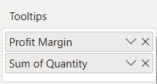

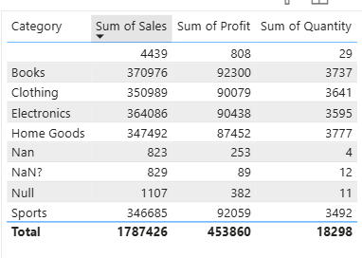

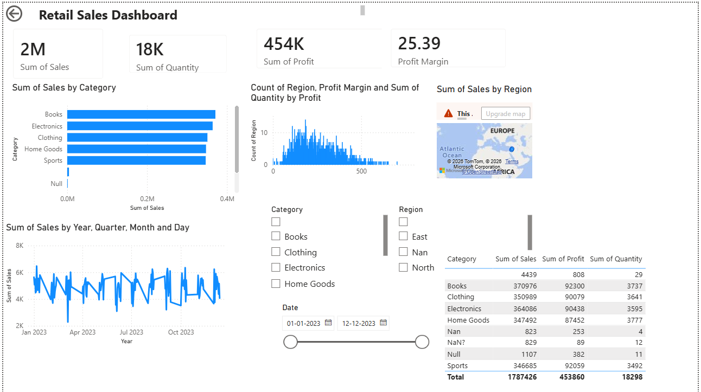

POST-LAB QUESTIONS (PROVIDE BRIEF ANSWERS TO THE FOLLOWING QUESTIONS)

- How did interactivity improve the analysis experience in your dashboard?
Interactivity made the dashboard more user-friendly by allowing users to explore the data according to their needs. Filters and slicers helped focus on specific regions, categories, or date ranges without changing the original data. Drill-down features enabled detailed analysis from yearly trends to monthly or daily performance. This made it easier to identify patterns, compare results, and make informed decisions quickly.
2. Which interactive feature (filters, drill-down, parameters, etc.) was most useful and why?
The most useful feature was the filters and slicers because they allowed quick analysis of different categories, regions, and time periods. Users could instantly update all visuals by selecting different options without creating multiple reports. This saved time and improved the overall user experience. It also made the dashboard more flexible for different analytical needs.
3. What challenges did you face while implementing drill-down or dynamic filters?
One challenge was ensuring that the data types were correctly set so that filters and calculations worked properly. Another issue was configuring the date hierarchy correctly for drill-down functionality. It was also important to verify that slicers interacted with all relevant visuals. Testing and adjusting visual interactions helped resolve these issues.
4. How do tooltips contribute to better dashboard storytelling?
Tooltips provide additional information without making the dashboard crowded. When users hover over a chart, they can see extra details such as sales, profit, or quantity for a specific data point. This helps users better understand the context of the visualizations. As a result, the dashboard becomes more informative and easier to interpret.
5. What additional features would you add to make the dashboard more insightful?
I would add forecasting to predict future sales trends and help with business planning. KPI indicators with target values would make it easier to monitor performance against goals. A customer or product-level analysis page would provide deeper insights if additional data were available. I would also include bookmarks and custom navigation buttons to improve the overall user experience.

RESULT:

The retail sales dataset was successfully transformed, aggregated, and visualized into interactive dashboards in Tableau and Power BI. Filters, slicers, drill-downs, and parameters enabled dynamic exploration of sales and profit trends by region, product category, and time period. The resulting dashboards allowed for quick insights and deeper analysis, enhancing decision-making capabilities.

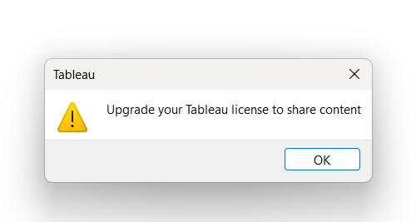

ASSESSMENT

Description |  | Max Marks | Marks Awarded
Pre Lab Exercise |  | 5
In Lab Exercise |  | 10
Post Lab Exercise |  | 5
Viva |  | 10
 | Total | 30
 | Faculty Signature

